Rochester Institute of Technology
EEEE-485 Tech Memo
From: Dylan Lebedin
Partner: None
To: Xavier — Thursday Section
Date: Performed: 9/26; Due: 10/3
Subject: Lab # 3
Abstract
The purpose of the lab was to interact with and gather data from sensors. There were four different sensors used to gather data. The sensors were wired to a Teensy 4.0 microcontroller and programmed in VS Code. An Ultrasonic sensor was used to measure how far an object’s distance was in inches. The sensor was pretty accurate having a plus-minus of 0.3 inches for the data readings. The next sensor used was the IR Distance Sensor, specifically the Sharp GP2Y0A21YK0F, which was used in the exact same manner as the Ultrasonic sensor. The IR Distance was also accurate having a plus-minus of 0.35 inches for the data readings. The third sensor to interact with was the VL53L0X LiDAR sensor, which was programmed to the teensy 4.0 so that when an object became closer to it, the LED on the teensy would blink at a faster rate. This exercise was successful, and the teensy LED blinked at a higher rate when an object was approaching the LiDAR. The last sensor used was the IR Reflection sensor, which was used to print a barcode based on the reflectance values of an object. This was also done successfully, as the sensor was fully able to detect the colors on the barcode in order to print out the correct values.
Theory
Every sensor used in the lab besides the IR Reflection sensor was a time of flight sensor. Time of flight sensors measures distance of an object by sending a signal and timing how long it takes to get back. It determines how long a signal propagates through a medium to determine the distance the signal travels. One type of time of flight sensor used was the ultrasonic sensor which uses sound to determine distance. To control the sensor, one outputs a pulse into the sensor that excites the speaker to send a pulse of an ultrasonic wave. When the wave is received, it pulls the signal line high. To measure the distance, one has to precisely time the difference between when the signal was sent out and when the pin goes high. The next time of flight sensor used was the VL530X LiDAR, which sends a pulse of light and times how long it takes before it comes back. Since it uses light, it is much faster and more accurate than other sensors and allows the robot to perform localization in real-time. The last time of flight sensor used was the Sharp GP2Y0A21YK0F IR Distance Sensor, which sends out an infrared signal and looks at the incoming signal to see any changes in its properties. Seeing how the properties changes allow the sensor to accurately measure distance; however, the sensor is only accurate between 10 and 80cm range. The last sensor used, which was not a time of flight sensor was the IR reflection sensor. This sensor works off the principle that infrared light can be reflected and absorbed differently. The sensors output a flood of infrared light and continuously measures the intensity of the reflection of the light.
Results and Discussion
For the first part of the lab, an IR Distance sensor was mounted onto a breadboard and wired to the Teensy 4.0 microcontroller. A while loop was used to periodically read the analog values from the sensor. In order to form an equation to measure how far an object was, a ruler was used to measure the readings between 2 and 7 inches. The readings as seen in Figure 1, were then inputted into Microsoft Excel, and a power fit was used to formulate an equation that had plus-minus 0.3in accuracy when tested.
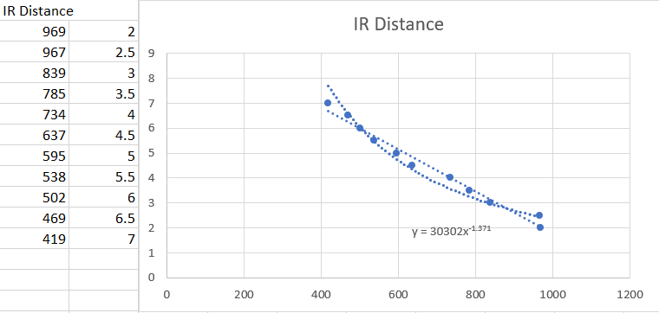
Figure 1 Readings and Equation Found from IR Distance Sensor
For the second part of the lab, an ultrasonic sensor was mounted onto a breadboard and wired to the Teensy 4.0 microcontroller. A digitalWrite () was used to send out at first a low pulse and then a high pulse from the trigger pin on the sensor, in order for the echo pin to read the high pulse from the sensor. The duration of the signal was found from the time it takes to send out the signal to the reception of the signals that echo off the object. In order to form an equation to measure how far an object was, a ruler was used to measure the readings between 4 and 12 inches. The readings as seen in Figure 2, were then inputted into Microsoft Excel, and a linear fit was used to formulate an equation that had plus-minus 0.35in accuracy when tested.
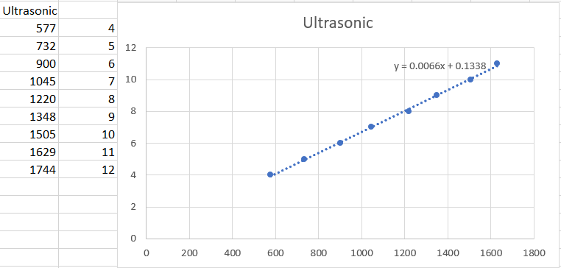
Figure 2 Readings and Equation Found from Ultrasonic Sensor
The third sensor used in the lab was the VL53L0X LiDAR which was mounted on a breadboard and wired to Teensy 4.0 microcontroller. The VL530X Library was installed in order to use methods such as the .readRangeContinuousMillimeter(), which allowed for the LiDAR to continuously read the LiDAR’s values. A digitalWrite () was used to set to the LED on the Teensy either high or low, with a delay of the distance value found by the LiDAR. This allowed the LED to blink faster when an object was closer to it, and slower when the object was farther away. The code implementation of the LiDAR can be seen in Figure 3.
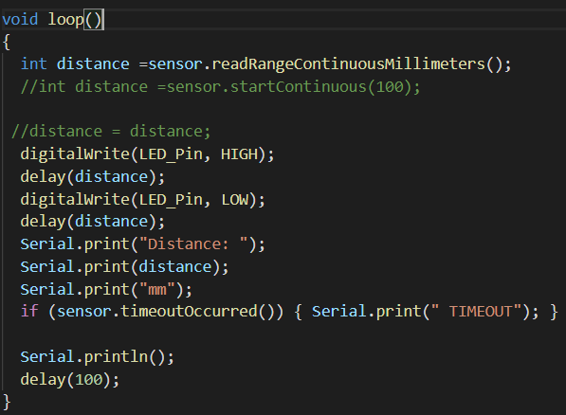
Figure 3 LiDAR Code
The last sensor used in the lab was the analog version of the IR Reflection sensor, which was programmed to read the reflectance values off a barcode, and then print the barcode based on the values found. This was done by doing an analogRead () of the sensor’s values of the colors black and white and then set a threshold, so that if they were in a certain range, the sensor would print out a specific color. The code implementation of this method can be seen in Figure 4.
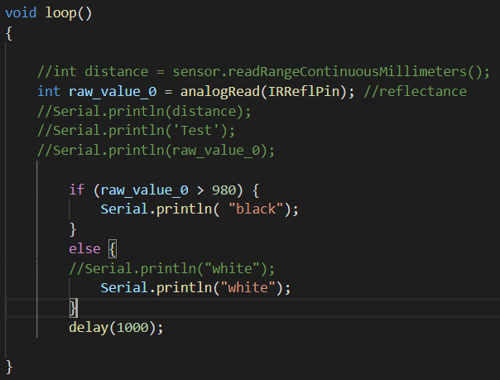
Figure 4 IR Reflection Code
The part of the lab that needs improving upon is that there should definitely be better documentation in the lab, telling us what it is we are supposed to do. It would have been better if it said in the lab document to print the values of the sensor, then use a ruler to record values at a certain distance, and make a graph with certain type of fit to input into your code. Also, if all the LiDAR sensors were working, I could have maybe made the last part of my lab more accurate by printing the section the color came from. Unfortunately, the LiDAR I used caused my serial to break, and I was stuck just using the analog version of the IR Reflection sensor.
Conclusions
The goal of the lab was to gather data and become more familiar with sensors. There was three time of flight sensors used. The first two, the IR Distance and the Ultrasonic both were used in order to determine the distance an object was from the sensor. Both were very accurate, with a maximum range of plus-minus 0.35 inches. The third time of flight sensor used was a LiDAR that was able to successfully blink at a faster rate when an object was closer to it, and slower when an object was farther away. The last sensor used the IR Reflection sensor, which with a programmed threshold was able to successfully read the colors and print the barcode. All the sensors were wired to the Teensy 4.0 microcontroller and programmed in VS Code. It was a very interesting lab, and it was interesting to see how sensors could be used for many different applications.
Appendix
- The IR Distance sensor would work great for really short distances specifically between 10 and 80cm. The Ultrasonic sensor would be good to use for small and midrange applications since it is accurate up to 3 meters. The LiDAR would work better for longer distances since it would be more accurate than the IR Distance and the Ultrasonic Sensor.
- Cameras such are a major one that could help perform computer vision type tasks such as tracking or identifying a certain object. Another one is an IMU that is used to find the tilt and rotation of a robot.

